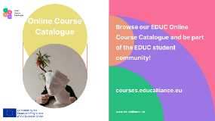
Exciting opportunities await in the
EDUC European University Alliance’s Online Course Catalogue!

Whether you are a passionate explorer of the arts, a future entrepreneur, or a science enthusiast, our diverse range of online EDUC online courses has something special for every one of you.

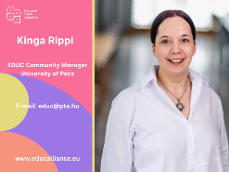
Do you have questions?

Contact our Institutional EDUC Office of the University of Pécs.

E-mail: educ@pte.hu

Visit the Course Catalogue, get ready for your new adventure, and be part of the EDUC community!

Follow the EDUC social media platforms at the links below for new opportunities!

↓

